Exercise

Q.01 Develop a program that repeatedly accepts daily expense amounts from the user, calculates the total monthly expenditure, and displays the number of expenses recorded.

total = 0
count = 0

while True:

expense = float(input("Enter expense (0 to stop): "))

if expense == 0:

break

total = total + expense

count = count + 1

print("\n----- MONTHLY EXPENSE -----")

print("Total Expenditure =", total)

print("Number of Expenses =", count)

output
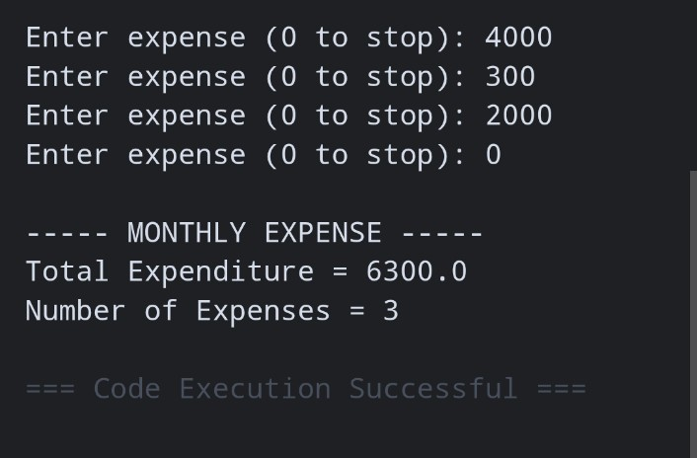

Q.02 Create a program that records expenses under different categories such as Food, Travel, and Shopping, calculates the total expense for each category, and displays a formatted monthly expense summary..

food = 0

travel = 0

shopping = 0

n = int(input("Enter number of expenses: "))

for i in range(n):

category = input("Enter category: ").lower()

amount = float(input("Enter amount: "))

if category == "food":

food = food + amount

elif category == "travel":

travel = travel + amount

elif category == "shopping":

shopping = shopping + amount

else:

print("Invalid category")

print("\n----- MONTHLY EXPENSE SUMMARY -----")

print("Food =", food)

print("Travel =", travel)

print("Shopping =", shopping)
print("Total =", food + travel + shopping)

output
